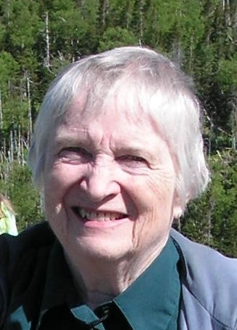
Marj Bone
Marj has served curling in Manitoba for many years. She has provided service where she was a paid employee, areas where she received an honorarium, and also served as a volunteer at the club and provincial level.
She was a member of the Curl Manitoba office staff from 2004-05 and 2012-13, a total of 9 years.
A computer programmer by trade, she created a draw program for the former MCA and MLCA, which is still in use today. She also created a program for the Hall of Fame whereby we have been able to create a database, which contains the names of all provincial participants and bonspiel trophy winners from 1888. This database and accompanying software provides access to the chronological history of individuals. This has allowed CurlManitoba to provide necessary information to members of the Manitoba Media as well as the Hall of Fame Selection Committee.
Since the MCA Bonspiel/Manitoba Open headquarters staff retired, CurlManitoba has paid her an honorarium for creating the spreadsheets and macros that replace the old program as well as providing support for the headquarters people.
Marj’s volunteer services are extensive.
She was a member of the Manitoba Curling Foundation for three years.
She has been a member of the Manitoba Ladies Past Presidents Curling Association executive since 2005-06, a period of 13 years, the past 9 years as their treasurer.
She has worked for the Hall of Fame in the cataloguing and recording of artifacts. She has helped set up displays at some of the Hall of Fame Dinners.
She was one of the first timekeepers to come onboard when timing was introduced. She worked as a timer at her first event back in 1990 with the chess clocks. Since 1991, she has worked at least one provincial championship per year as a timer, a span of over 28 years.
She has been a timer at all Grand Slams held in Winnipeg, the 1991 and 2003 World Curling Championships, the 2008 Tim Horton’s Brier, and the 2013 Olympic Curling Trials.
At the club level, Marj has held positions at CFB Shilo, Wildewood, and Deer Lodge. She was President of the CFB Shilo Ladies’ Leagues in 1972-73 and President of Deer Lodge Business Girls in 1992-93. She has been the draw master for the Deer Lodge Business Girls for over 20 years. She was the Coke Classic timer/umpire chair and the 2009-10 Provincial Junior Men’s timer chair, both hosted by Deer Lodge.

