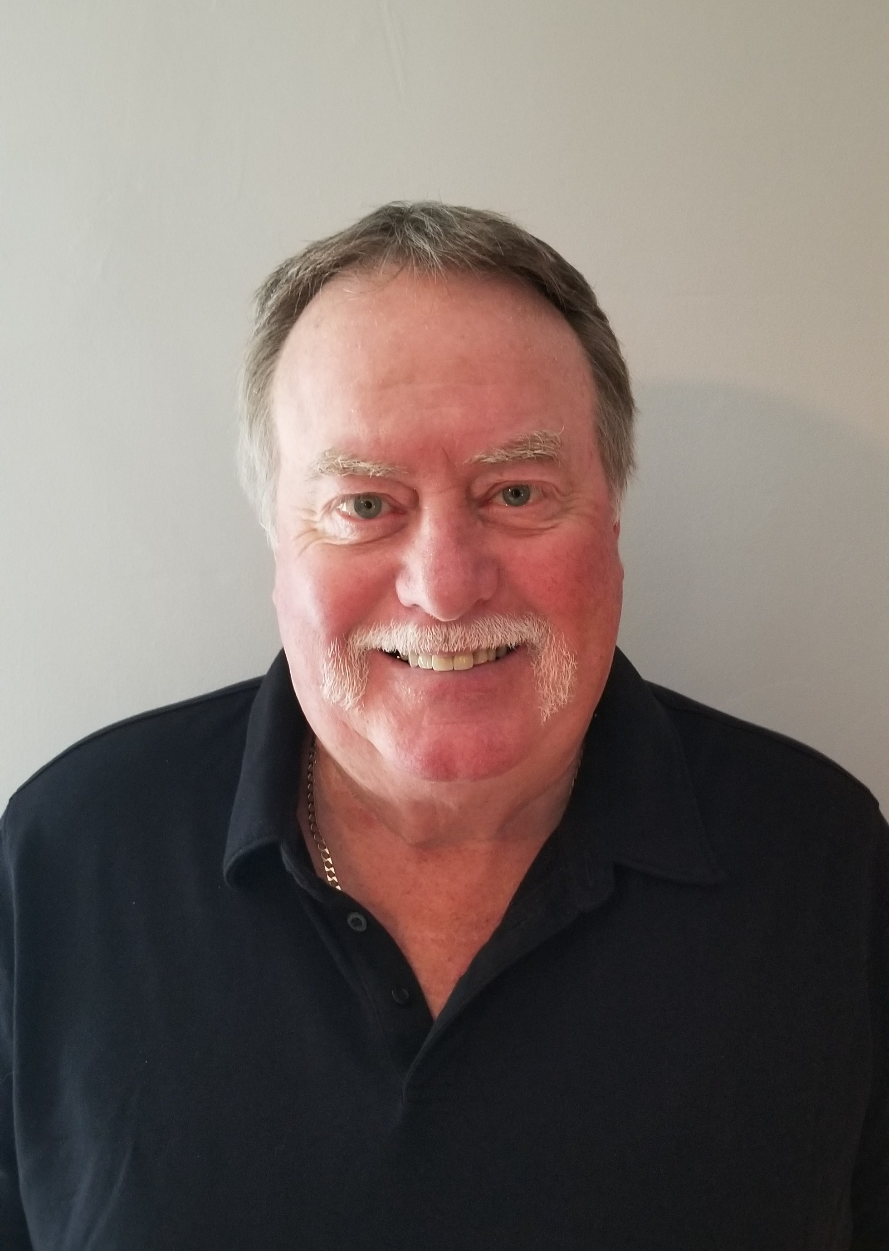

Murray McLeod Springfield Curling Club

Murray started curling at the Springfield club in the 1960s and enjoyed many years playing the game. He participated in Club, Zone/ Regional and Bonspiels over the years qualifying for the Provincials in Men's, Mixed and Senior Men's.

He served on the Executive of the Club from 1992–2015 and was elected as President for two separate terms and continue as an executive member of the Men's Leagues.

He received a Honourary Life Membership with the Springfield Curling Club in 2014.

In 1998, he began serving as the Zone Chairman for the Eastman Region. He chaired the Men's and Mixed play downs for over 10 years and in 2004 the Senior Men's/Women's for seven years. He served on the Board of Directors for the MCA/MLCA for two years.

Murray accepts and appreciates this recognition from Curl Manitoba.

