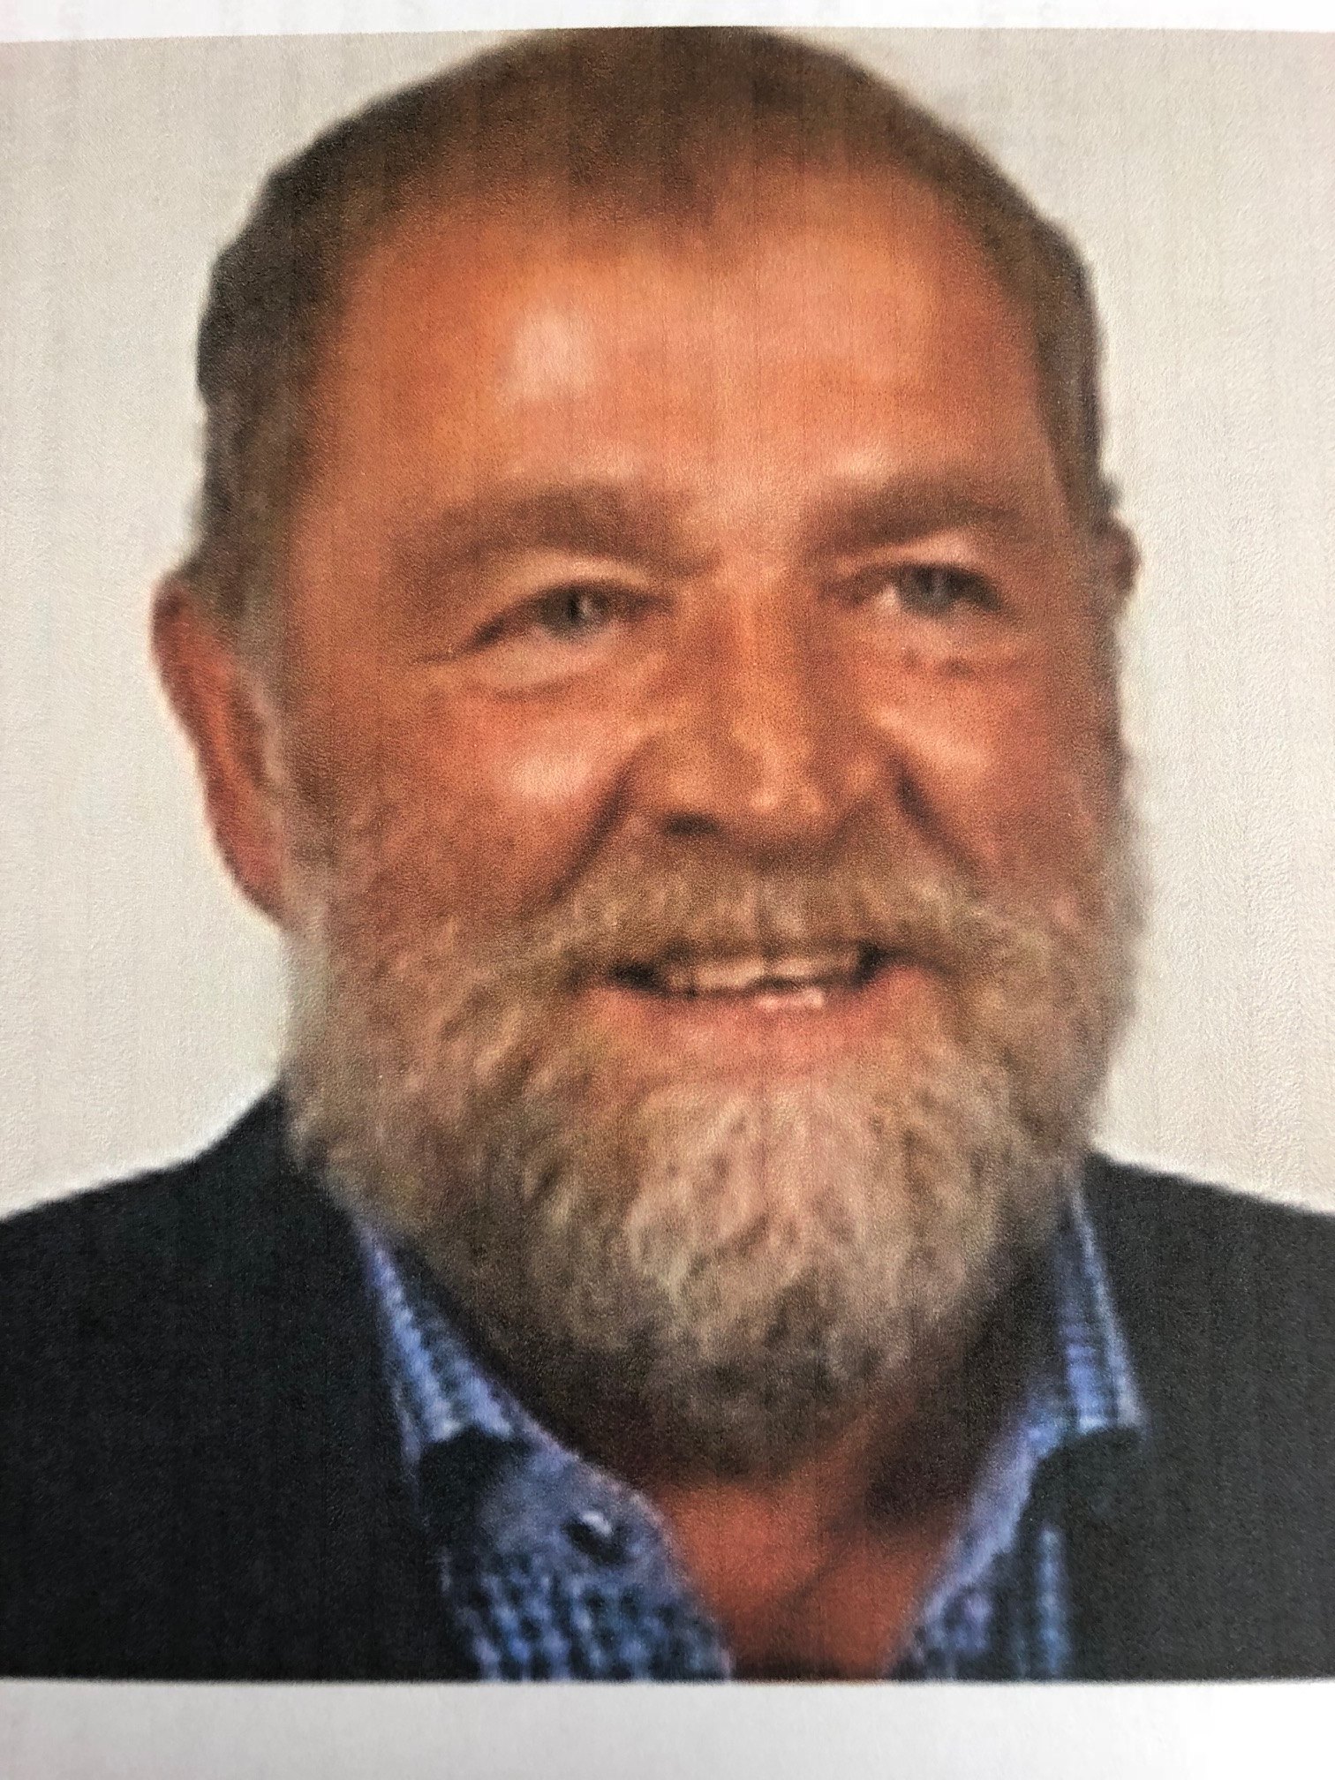

Terry Peters

I really only started with the Altona Curling Club in 1987. That was my first year of curling and after that I agreed to let my name stand for a position on the executive. Two years later, I was elected President of the club for a two-year term. I have been fairly involved in curling in the area ever since. In 1997, I took over as club icemaker and later added the Club Manager position to my portfolio.

In 1996, my brother and I stated holding fish fry's, six a year, and 22 years later we are still at it. Tuesdays before the fry, six hours of prep work. Wednesdays of the fry's is eight hours in the kitchen.

In 2003, we moved to the new facility and I helped in the design of the lounge and kitchen.

Provincially, I was involved in setting up the Altona Men's and Women's cash spiel, on the MCT circuit during the mid 1990s. I also served as men's zone chairman for a period of 14 years. As a club, we have hosted many provincial championships events, being the Senior Men's and Ladies, Master Ladies, Scotties, Junior Men's and Women's and I served as head icemaker for all of those events. I also assisted Hans and Greg in arena events. I was a volunteer at the Canadian Mixed held in Morris as well as the provincial Ladies and Men's events held in Winkler.

